BOARD OF SUPERVISORS
COUNTY OF LAKE, STATE OF CALIFORNIA ORDINANCE NO. 1462
"AN ORDINANCE ADDING ARTICLE VI TO CHAPTER 9 OF THE LAKE COUNTY CODE
ESTABLISHING A CROSS-CONNECTIO�'CONTROL PROGRAM TO PROTECT THE PUBLIC WATER SYSTEMS”
6
7 THE BOARD OF SUPE�VISORS OF THE COUNTY OF LAKE, STATE OF CALIFORNIA, DOES
8' ORDAIN AS FOLLOWS:
9: SECTION 1. Article VI is hereby added to Chapter 9 of the Ordinance
10 Code of the County of Lake to read as follows:
11 "ARTICE :VI - PROTECTION OF PUBLIC WATER SYSTEMS
12
-
.......
,.

13
14
15
'. 16:
!'
40.1
Pursuant to section 450 of the California Health and Safety Code
and Title 17, section 1174 et .seq. of the California Administrative Code
'·
� •. •
- _:o_.
a Cross-connection Control Program is established in the County of Lake for the following purposes:
0


•'·j
'• i
..I
17
18·
19·
20
21
22
23
- to protect the public water supply against actual or potential cross-connections by isolating within the premises contamination or pollution that may occur because of some undiscovered or unauthorized cross-connection on the premises;
- to eliminate existing connections between drinking water systems and other sources of water that are not approved as safe and
potable for human consumption;

I
- I

:,• ,•

- I
24.
25

26
27
28 II

,'
- to eliminate cross-connections between drinking water systems
and other sources of water or process water used for any purpose what-soever which jeopardize the safety of the drinking water supply; and
- to prevent the making of cross-connections in the future.

-1-.
'

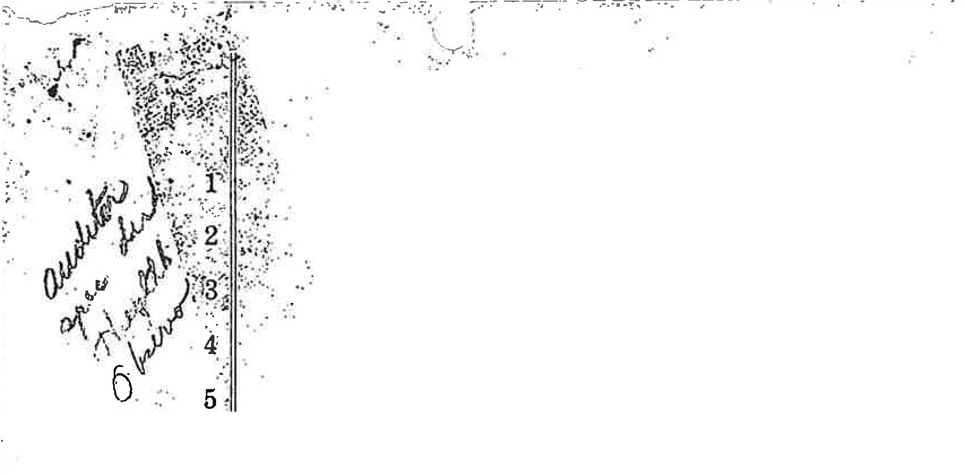



- -':..!. -
·.'·
=:_.
,:
.,
.....

.·'-•
:,
" I
'..'.
:'
.I
:,
. ·f
. •,
·
;,
,
...11:
•i1
)I
. •�Jt
,;;�
' ;·,
.:,
•
··t,i
·;,1,
_.· - -
  - : -- _!
--· :..._ -- .• -� �·•• ..;,;

- ·· ·
t

Ordinance No.

1462

Cross-connection

1
2
3
4
5
6
7
8
9
10
11
12
13
14
15
16
17
18·
19
20
21
22
23
24
25
26
27
28

41.1
Section 9-41. Definitions.
For the purposes of this Article, the following terms shall have the following meanings:
- Cross-connection means any unprotected connection between any part of a water system used or intended to supply water for drinking purposes and any source or system containing water or substance that is not or cannot be approved as safe, wholesome, and potable for human consumption.
- Approved water supply means any water supply approved by or under the public health supervision of a public health agency of the State of California, or its political subdivisions. In determining what constitutes an approved water supply, the State Department of Public Health reserves final judgment as to its safety and potability.
- Auxiliary supply means any water supply on or available to the premises other than a public water supply.
- Approved check valve means a check valve that seats readily and completely and has been approved for use in County Service Areas.
- Approved double check valve assembly means an assembly of at least two independently acting approved check valves including tightly closing shut-off valves on each side of-the check valve assembly and suitable leak-detector drains plus connections available for testing the water tightness of each check valve.
- Air-gap separation means a physical break between a supply pipe and a receiving vessel. The air-gap shall be at least double the diameter of the -supply pipe measured vertically above the top rim of the vessel, in no case less than one inch.
- Approved reduced pressure principle backflow prevention device means a device incorporating two or more check valves and an automatically
-2-

;':

1
2
3
4
5
6
7
8
9
10
11
12
13
14
15
16
17

r·
18 • 42.1
19
20
21
22
23 42'. 2
24
25
26
27
28
Ordinance No. 1462 Cross-connection


operating differential relief valve located between the two checks, two shut-off valves, and equipped with necessary appurtenances for testing. The device shall operate to maintain the pressure in the zone between the two check valves less than the pressure on the public water supply side of the device.
------
- Approved backflow device means:
  - An approved double check valve assembly; or
  - An approved air-gap separation; or
  - An approved reduced pressure principle backflow prevention device.
- County water system means a system of water delivery operated · and maintained by a County Service Area formed pursuant to section
25210.1 et seq. of the Government Code of the State of California.
- Premise or premises means land and everything appurtenant thereto, including but not limited to, buildings, structures, and mobilehomes.
Section 9-42. Cross-connection and Protection Requirements.
Except as otherwise provided by this Article, no person or entity shall cause a connection to be to be made between plumbing pipes, plumbing fixtures or appurtenances thereof served with water supplied by a county water system and plumbing pipes, plumbing fixtures or appurtenances thereof served by any other source of water.
Except as otherwise provided by this Article, no person or entity shall install or use any plumbing pipes, plumbing fixtures or appurten-ances thereof which by their construction or means of hook-up, may permit a backflow of water or any other liquid or substance into a county water system or into the service system of a consumer of water from such system.
-3-

.,.


Ordinance NoJ.462 Cross-connection
------

1·
2 43.1
3
4
Section 9-43. Permit Required for Cross-connection.
Any person or entity that installs or maintains a cross-connection on any premises shall obtain a permit for such cross-connection from the County Utilities Manager.

5
6
7
8
9
10
11
12
13
14
15
16
,. 17
18·
19
20
21
22
23
24
25
26
27
28
43.2

43.3
As a condition for the issuance of such permit, the person or entity wishing to maintain a cross-connection shall install an approved backflow prevention device.
Installation of an approved backflow prevention device shall be required under the following circumstances:
- An approved backflow prevention device shall be installed at each service connection of a county water system where the premises served is also served by an auxiliary water supply not approved by the public health agency having jurisdiction.
- An approved backflow prevention device shall be installed at each service connection of a county water system where the premises served has upon it any liquid or substance under pressure which may enter a county water system. Such liquid or substance includes, but is not limited to, waters originating from a county water system which have been contaminated below the health standards established for a county water system.
- An approved backflow prevention device shall be installed
at each service connection of a county water system where the premises served has upon it a cross-connection; provided however, no backflow prevention device is required pursuant to this subdivision where such cross-connection has been-modified to prevent any contamination of a county water system and such modification has been approved, in writing, by the County Utilities Manager and has been approved by the State or County Health Department.
-4-

,1 !

Ordinance No. 1462
Cross-connection

1· Section 9-44. Requirements for Installation of Backflow Prevention Device

,..
2
3
4
5
6
7
8
9
10
11
12
13
14
15
16
17
18·
19
20
21
22
23
24
25
26
27
28
44.1
When a backflow prevention device is required to be installed pursuant to this Article, the following shall apply:
- Any person or entity that is required to install a backflow prevention device pursuant to this Article shall first obtain a permit for such installation from the County Utilities Manager.
- Any backflow prevention device installed must be approved by the Foundation for Cross-connection Control and Hydraulic Research of the University of Southern California.
- Any backflow prevention device shall be installed in accordance with the methods of installation prescribed in the "Manual of Cross-Connection Control Procedures and Practices" prepared by the California State Department of Health Services Sanitary Engineering Section or as prescribed and approved in writing at his discretion by the County Utilities Manager.
- Any person or entity which owns any premises where a backflow prevention device has been installed shall have such device inspected annually by a Certified Inspector pursuant to the applicable Rules and Regulations of the California State Department of Public Health. A written report of the inspection shall be filed by the owner of the premises with the County Utilities Manager on the second Monday of each January of each year the device remains installed.
- The County shall not be liable for any costs for the inspection, repair, or maintenance of any backflow prevention device installed pursuant to this Article. All such costs shall be borne by the owner of the premises.
-5-

·- - • ··---···-··-·-······. ··--·-- ---· -·-·

Ordinance No. 1462
Cross-connection

1
2 5.1
3
4
5
Section 9-45. Installation of Backflow Prevention Devices for Premises with Existing Cross-connections.
Upon adoption of this Article, the County Utilities Manager shall conduct a survey of all premises affected by the requirements of this Article to determine those premises which have an actual or potential cross-connection.

- 45.2 The owner of each premises as determined by the County Utilities
- Manager shall install or cause to be installed an approved backflow
- ·prevention device within one (1) year from the effective date of this
- Article.

10
11
12
13
14
15
16
17
t'
18·
19
20
21
22
23
24
25
26
27
28
45.3

45.4
Upon the determination by the County Utilities Manager that a back-flow prevention device is required upon the premises, the County Utilities Manager shall serve notice upon the owner of said premises, as determined from the last assessment roll, by depositing in the mail, postage prepaid, certified, return receipt requested, a notice that the premise has been determined to be subject to the provisions of the Article and the steps the owner of the premise must take to comply with such provisions.
After receiving the notice required by section 45.3, above, the owner of the premises shall do one of the following:
- Obtain a permit pursuant to the provisions of this Article,
and install the device following the procedures set forth in section 44.1, subdivision (c) of this Article. The total cost of such installation shall be borne by the owner of the premises; or
- Request the County Utilities Manager to install the device; provided however, the owner of the premises shall be liable only for those costs incurred for purchase of the materials used for such installation. Upon installation, the owner of the premises shall be responsible for all costs of inspection, repair, and maintenance
of the backflow prevention device.
-6-

-!

-------·-· ···- •• ········· ·-
..
..

Ordinance No. Cross-connection

1462

1
2 46.1
3
4
5
6
7 47.1
8
9
10
11
12
13
14
15
16 48.1

17
t'
J·

18·
19
Section 9-46. Discontinuance of Service.
Service of water to any premises served by a county water system may be discontinued for non-compliance with the provisions of this Article.
Service shall be restored only upon compliance with the provisions of this Article.
Section 9-47. Right-of-Entry.
The County Utilities Manager, or his designee, shall inspect premises for non-compliance with the provisions of this Article. He shall carry proper credentials of his office, upon exhibition of which he shall have the right of entry, during usual business hours, to inspect all premises in the performance of his duty. This right of entry shall be a condition of water service in order to provide assurance that the continuation of service to the premises will not constitute a menace to the health,
safety and welfare of the people throughout a county water system. Section 9-48. Certification of Tester.
Each applicant for certification as a tester of backflow prevention devices shall file an approved application with the Environmental Health Division of the County Health Department together with a fee as may be established by the Board of Supervisors.

20 48.2
21
22
23
24

25
26
27

28
Competency in all phases of backflow prevention device testing and repair must be demonstrated by means of education or experience, or both, in order to obtain certification. The following are minimum requirements:
- Applicants shall have had at least two (2) years experience in plumbing or pipe fitting or equivalent qualifications;
- Applicants shall hold a valid certification from the American Water Works Association, California-Nevada Section, or satisfactory completion of the Course for the Training and Certifica tion of Testers for Backflow Prevention Devices offered by the
-7-

..;

.. --··

. ···- ··- • ···
.,..' Ordinance No. -14-6-2 ----
Cross-connection

1
2
3
4
5
6
7
8
9 48.3
10
11
12
13
14
15
16
Foundation for Cross-connection Control and Hydraulic Research, University of Southern California, or have equivalent training as determined by the County Utilities Manager and the Director of the Lake County Health Department or his authorized designee; and
- Each applicant shall furnish evidence to show that he has available the necessary tools and equipment to properly test such devices. He shall be responsible for the competency and accuracy of all tests and reports prepared by him.
The certificate issued to any tester is valid for a period of one
- year from date of issuance. The certificate, may be revoked, suspended or not renewed for unsatisfactory testing, unsatisfactory repairs, or filing a report that misrepresents the condition of the device tested:
SECTION 2. SCOPE
This Ordinance shall apply to all COUNTY SERVICE AREAS.
SECTION 3. All ordinances or parts of ordinances or resolutions or p�ts

  - of resolutions in conflict herewith are hereby repealed to the extent of such
  - . conflict and no further.

19
20 11
SECTION 4. This Ordinance shall take effect on the 9th day of
May ; 1985, and before the expiration of fifteen (15)

- days after its passage, it shall be published at least once in a newspaper of
- general circulation in the County of Lake.
- 11·
- II
- II
- II
- II
- II
-8-
.j

Ordinance No. 14 6 2
' '
Cross-connection
- The foregoing Ordinance was introduced before the Board �f Supervisors
- ---='----- .......::.:=--------
on the 2nd day of April 1985, and passed by the

- following vote on the 9th day of Aril, 1985:

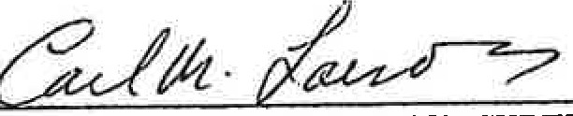
- AYES: Supervisors Brumfield, Wilcox, Mackey, Franklin & Larson
- NOES: None
- ABSENT OR NOT VOTING: None
7
8
Chairman, BOARD OF SUPERVISORS
9

10
11
12 ATTEST: LOIS R. HESTERBERG
County Clerk
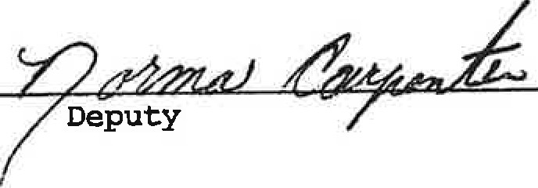
13
14 By:

15
16
,r 'i
17
18· APPROVED AS TO FORM: CAMERON L. REEVES I
  - 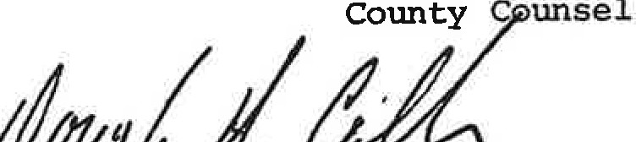
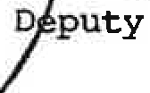
20 11--��?:....l-,rLl--¥-/--!-..l.,di���----
- //
- //
- 11·
- //
- //
- //
- //
- //
-9-

·-· ,

